How to storage Binary Files

[Git Large File Storage | Git Large File Storage (LFS) replaces large files such as audio samples, videos, datasets, and graphics with text pointers inside Git, while storing the file contents on a remote server like GitHub.com or GitHub Enterprise.](https://git-lfs.github.com/)

[Work with large files in your Git repo - Azure Repos | Microsoft Docs](https://docs.microsoft.com/en-us/azure/devops/repos/git/manage-large-files?view=azure-devops)

[Git LFS | Overview of Git Large File Storage | Perforce](https://www.perforce.com/blog/vcs/how-git-lfs-works)

[Why is the .git/index file binary? - Quora](https://www.quora.com/Why-is-the-git-index-file-binary)

[Tìm hiểu Git LFS - Thien An Blog](https://thienanblog.com/thu-thuat/thu-thuat-lap-trinh/tim-hieu-git-lfs/)

[Managing large binary files with Git - Intellipaat](https://intellipaat.com/community/11298/managing-large-binary-files-with-git)

Weakness:

* Git can store binary files, but you lose a lot of the functionality when you do so. As an example, if you store an .xlsx file in git, it won't be able to do any intelligent merging of changes to the file, which may undermine the usefulness of storing the file in git.

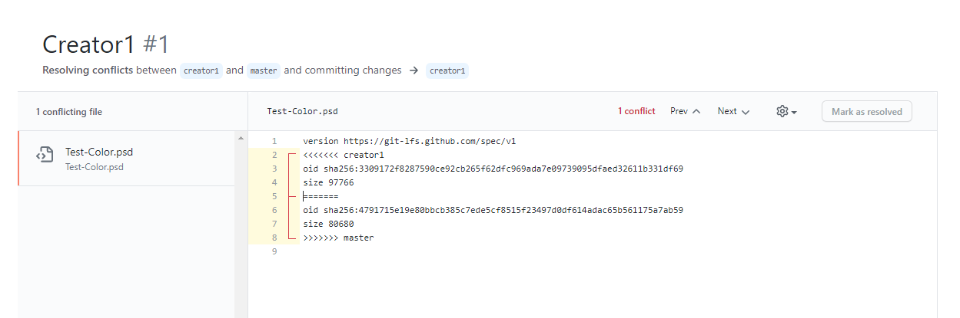

Strong: